Experiment No 3
Roll No:24141030 Lab: PL-II

Theory:

1. Introduction to Strings
A string is a sequence of characters enclosed in single quotes (' '), double quotes (" "), or triple quotes (''' ''' or """ """). Strings are one of the most commonly used data types in Python for handling text data.
Examples:
str1 = 'Hello'

2. Characteristics of Strings
Property | Description
Immutable | Strings cannot be changed after creation
Ordered | Characters have positions (indexes)
Indexable | Access characters using index (0-based)
Iterable | Can loop through characters

3. String Indexing and Slicing
Each character in a string has an index. Python supports both positive and negative indexing.
Index Type | Description | Example for "Python"
Positive | Starts from 0 from left | P(0), y(1), t(2), h(3), o(4), n(5)
Negative | Starts from -1 from right | P(-6), y(-5), t(-4), h(-3), o(-2), n(-1)
Slicing Syntax: string[start:end:step]
Slice | Output for "Python"
[0:4] | "Pyth"
[2:] | "thon"
[:4] | "Pyth"
[::-1] | "nohtyP"

4. Common String Methods
Method | Description | Example
len() | Returns length of string | len("Hello") → 5
upper() | Converts to uppercase | "hello".upper() → "HELLO"
lower() | Converts to lowercase | "HELLO".lower() → "hello"
capitalize() | Capitalizes first letter | "hello".capitalize() → "Hello"
title() | Capitalizes each word | "hello world".title() → "Hello World"
strip() | Removes leading/trailing whitespace | " hi ".strip() → "hi"
lstrip() | Removes leading whitespace | " hi ".lstrip() → "hi "
rstrip() | Removes trailing whitespace | " hi ".rstrip() → " hi"
split() | Splits string into list | "a,b,c".split(",") → ['a','b','c']
join() | Joins list into string | "-".join(['a','b']) → "a-b"
replace() | Replaces substring | "hello".replace("l","x") → "hexxo"
find() | Finds substring index | "hello".find("e") → 1
count() | Counts occurrences | "hello".count("l") → 2
startswith() | Checks prefix | "hello".startswith("he") → True
endswith() | Checks suffix | "hello".endswith("lo") → True
isalpha() | Checks if all alphabetic | "abc".isalpha() → True
isdigit() | Checks if all digits | "123".isdigit() → True
isalnum() | Checks if alphanumeric | "abc123".isalnum() → True

5. String Concatenation and Repetition
Operator | Description | Example
+ | Concatenates strings | "Hello" + " World" → "Hello World"
* | Repeats string | "Hi" * 3 → "HiHiHi"

6. Escape Sequences
Escape Sequence | Meaning
\n | New line
\t | Tab
\\ | Backslash
\' | Single quote
\" | Double quote

7. String Formatting
Method 1: f-strings (Python 3.6+
name = "Alice"
age = 25
print(f"My name is {name} and I am {age} years old")

Method 2: format() method
print("My name is {} and I am {} years old".format(name, age))

Method 3: % formatting (old style)
print("My name is %s and I am %d years old" % (name, age))

Programs and Code:

1. Program to find length of a string
s = input("Enter a string: ")
print(f"Length of string: {len(s)}")
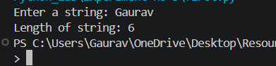
2. Program to reverse a string
s = input("Enter a string: ")
reversed_s = s[::-1]
print(f"Reversed string: {reversed_s}")
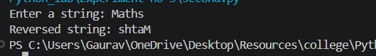
3. Program to check whether a string is palindrome
s = input("Enter a string: ").lower().replace(" ", "")
if s == s[::-1]:
print("String is Palindrome")
else:
print("String is not Palindrome")
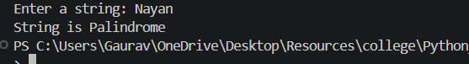
4. Program to count vowels and consonants in a string
s = input("Enter a string: ").lower()
vowels = "aeiou"
vowel_count = 0
consonant_count = 0
for ch in s:
if ch.isalpha():
if ch in vowels:
vowel_count += 1
else:
consonant_count += 1
print(f"Vowels: {vowel_count}")
print(f"Consonants: {consonant_count}")
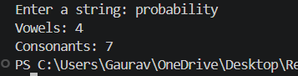
5. Program to convert string to upper and lower case
s = input("Enter a string: ")
print(f"Uppercase: {s.upper()}")
print(f"Lowercase: {s.lower()}")
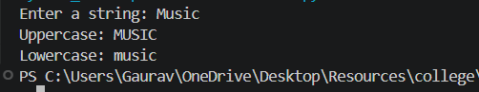
6. Program to count frequency of characters in a string
s = input("Enter a string: ")
freq = {}
for ch in s:
freq[ch] = freq.get(ch, 0) + 1
print("Character frequency:")
for char, count in freq.items():
print(f"'{char}': {count}")
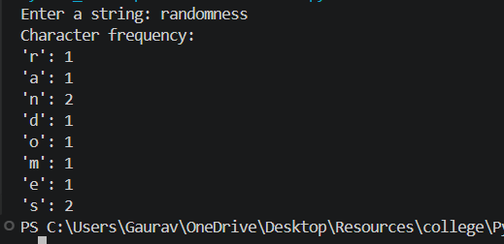
7. Program to remove spaces from a string
s = input("Enter a string with spaces: ")
no_spaces = s.replace(" ", "")
print(f"String without spaces: {no_spaces}")
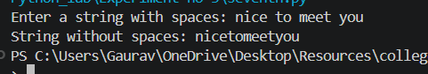
8. Program to replace a word in a string
s = input("Enter a string: ")
old_word = input("Enter word to replace: ")
new_word = input("Enter new word: ")
result = s.replace(old_word, new_word)
print(f"Modified string: {result}")
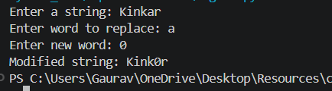
9. Program to split and join strings
s = input("Enter a sentence: ")
words = s.split()
print(f"Splitted words: {words}")
delimiter = input("Enter delimiter for joining: ")
joined = delimiter.join(words)
print(f"Joined string: {joined}")
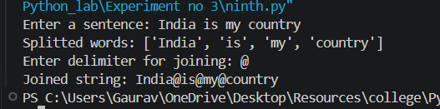
10. Program to check whether two strings are anagrams
s1 = input("Enter first string: ").lower().replace(" ", "")
s2 = input("Enter second string: ").lower().replace(" ", "")
if sorted(s1) == sorted(s2):
print("Strings are Anagrams")
else:
print("Strings are not Anagrams")
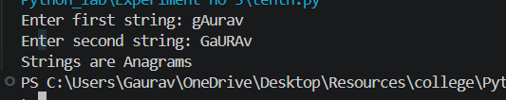

Conclusion
In this experiment, we studied string manipulation techniques including finding length, reversing strings, palindrome checking, case conversion, character frequency counting, removing spaces, replacing words, splitting/joining, and anagram checking. These operations are essential for text processing applications like data cleaning, text analysis, and natural language processing.

